भारतमौसमविज्ञानविभाग |  | India Meteorological Department
Friday, 27th June 2025 (6th Ashadha 1947 Saka)
Summary of observations recorded at 0830 hours IST: The Northern Limit of Monsoon continue to pass through 27.0°N/68.5°E, 27.0°N/70.0°E, Jaisalmer, Bikaner, Jhunjhunu, Bharatpur, Rampur, Sonipat, Anup Nagar and 29.0°N/70.0°E. Conditions are favourable for further advance of Southwest monsoon over remaining parts of the country during next 3- 4 days. The upper air cyclonic circulation lay over southwest Rajasthan of today morning. It then persisted over the same region and extended upto 5.8 km above m. s. l. tilting southwest wards with height. An east-west trough ran from the cyclonic circulation over southwest Rajasthan to Bangladesh across east Rajasthan, north Madhya Pradesh, north Jharkhand, Gangetic West Bengal and extended upto 5.8 km above m. s. l. tilting southward with height. The low-pressure area over Northwest Bay of Bengal and adjoining coastal areas of Odisha and West Bengal lay over north Odisha and adjoining Gangetic West Bengal with the associated cyclonic circulation extended upto 5.8 km above m. s. l. tilting southward with height at 0530 hours IST of today, the 27th June 2025. It then became less marked. However, the associated upper air cyclonic circulation merged with the mentioned trough. The trough from southeast Arabian Sea to Odisha across south Gujarat, northern parts of Madhya Maharashtra, Vidarbha, Chhattisgarh between 4.5 & 5.8 km above m. s. l. merged with the above-mentioned trough. A fresh upper-air cyclonic circulation is likely to develop over north Bay of Bengal and adjoining coastal Bangladesh & West Bengal around 29th June, 2025. Under its influence a low-pressure area is likely to form over the same region during subsequent 24 hours. The upper air cyclonic circulation over northeast Madhya Pradesh at 0.9 km above m. s. l. became less marked.
Day temperatures were markedly above normal (> 5.1°C) at few places over Arunachal Pradesh; at isolated places over Assam & Meghalaya and Odisha. appreciably above normal (3.1°C to 5.0°C) at few places over sub Himalayan West Bengal & Sikkim; at isolated places over Himachal Pradesh, Jammu- Kashmir-Ladakh-Gilgit-Baltistan-Muzaffarabad and Tamil Nadu, Puducherry & Karaikal. above normal (1.6°C to 3.0°C) at isolated places over Nagaland, Manipur, Mizoram & Tripura, Bihar, Uttarakhand, Madhya Maharashtra and Rayalaseema. near normal (-1.5°C to 1.5°C) at many places over Haryana-Chandigarh-Delhi and West Rajasthan; at most places over Gangetic West Bengal, east Uttar Pradesh, west Uttar Pradesh, Konkan & Goa, coastal Karnataka and Lakshadweep; at few places over Andaman & Nicobar Islands, Saurashtra & Kutch, Coastal Andhra Pradesh & Yanam, north interior Karnataka and south interior Karnataka; at isolated places over Punjab, east Rajasthan, Marathwada, Chhattisgarh and Telangana. Yesterday, the highest maximum temperature of 41.3°C was reported at Jaisalmer (Rajasthan).
The Southwest Monsoon has been active over west Madhya Pradesh, Saurashtra & Kutch, Vidarbha and Kerala. It has been subdued over Arunachal Pradesh and Assam & Meghalaya.
Total 317 Station reported rainfall today. Total rainfall is 320.2 cm. Total 305 station reported rainfall today whose normals are available. Total rainfall is 292.9 cm with normal station total is 263.3 cm.
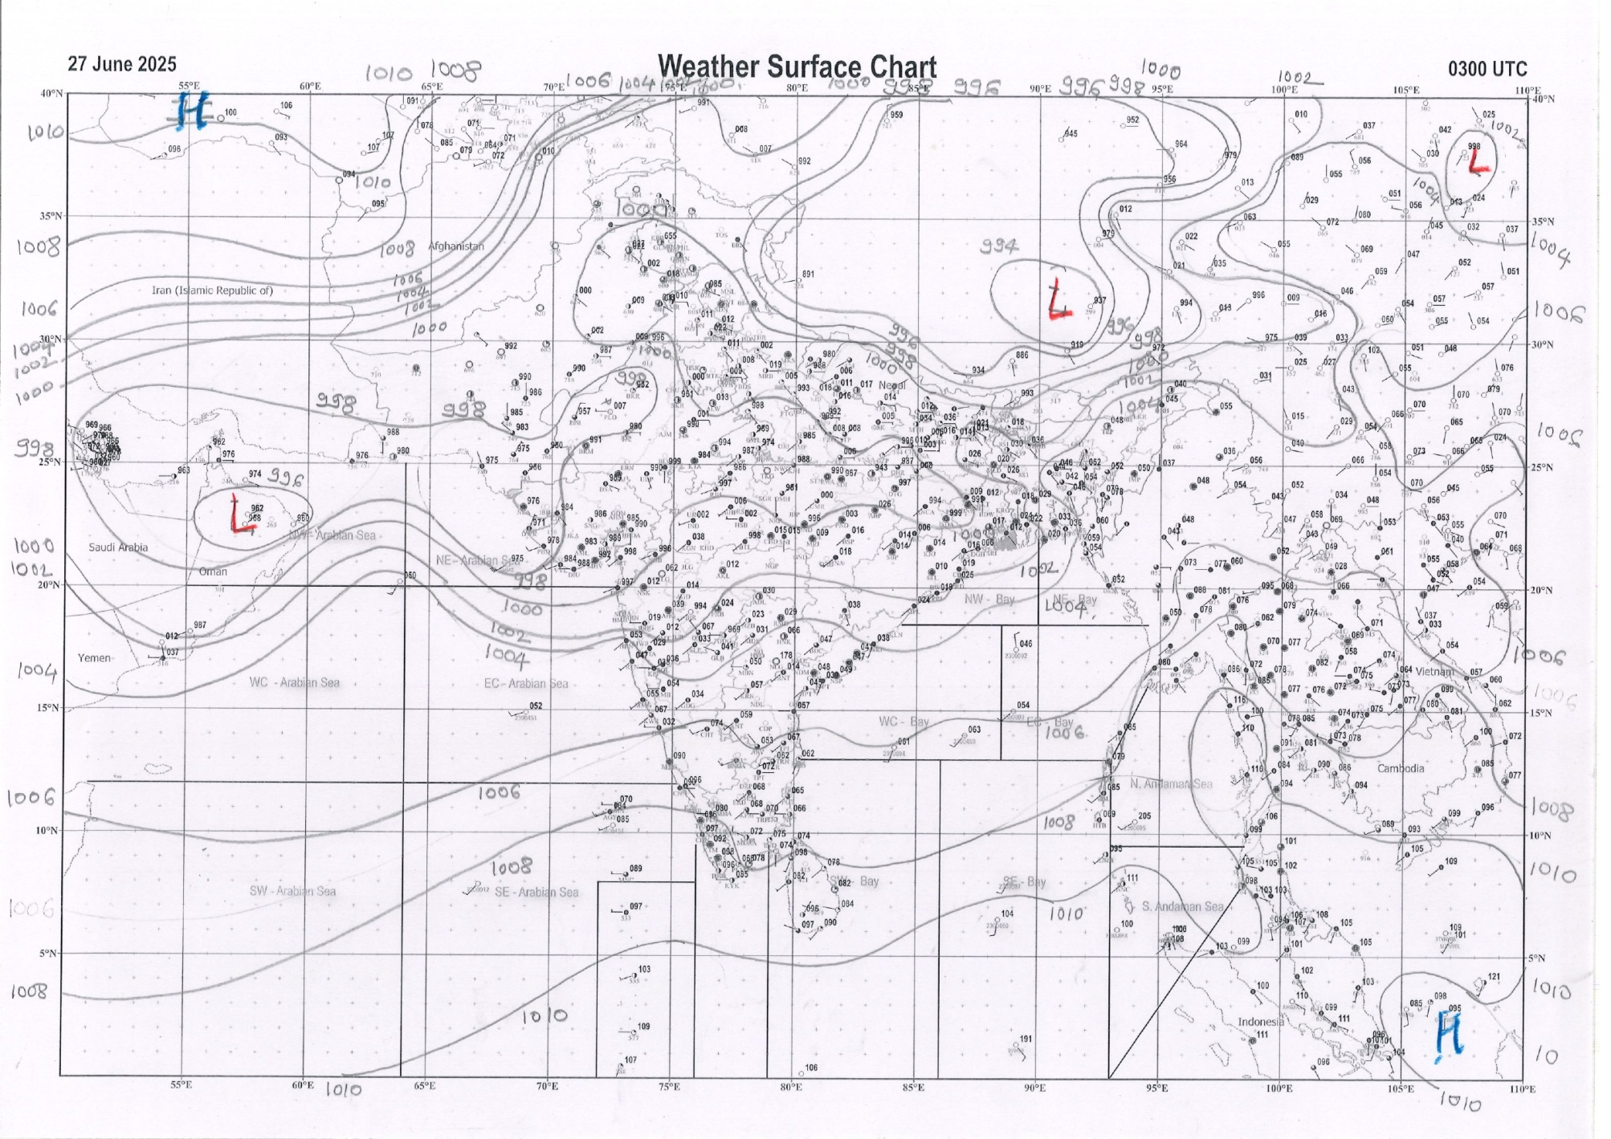 | 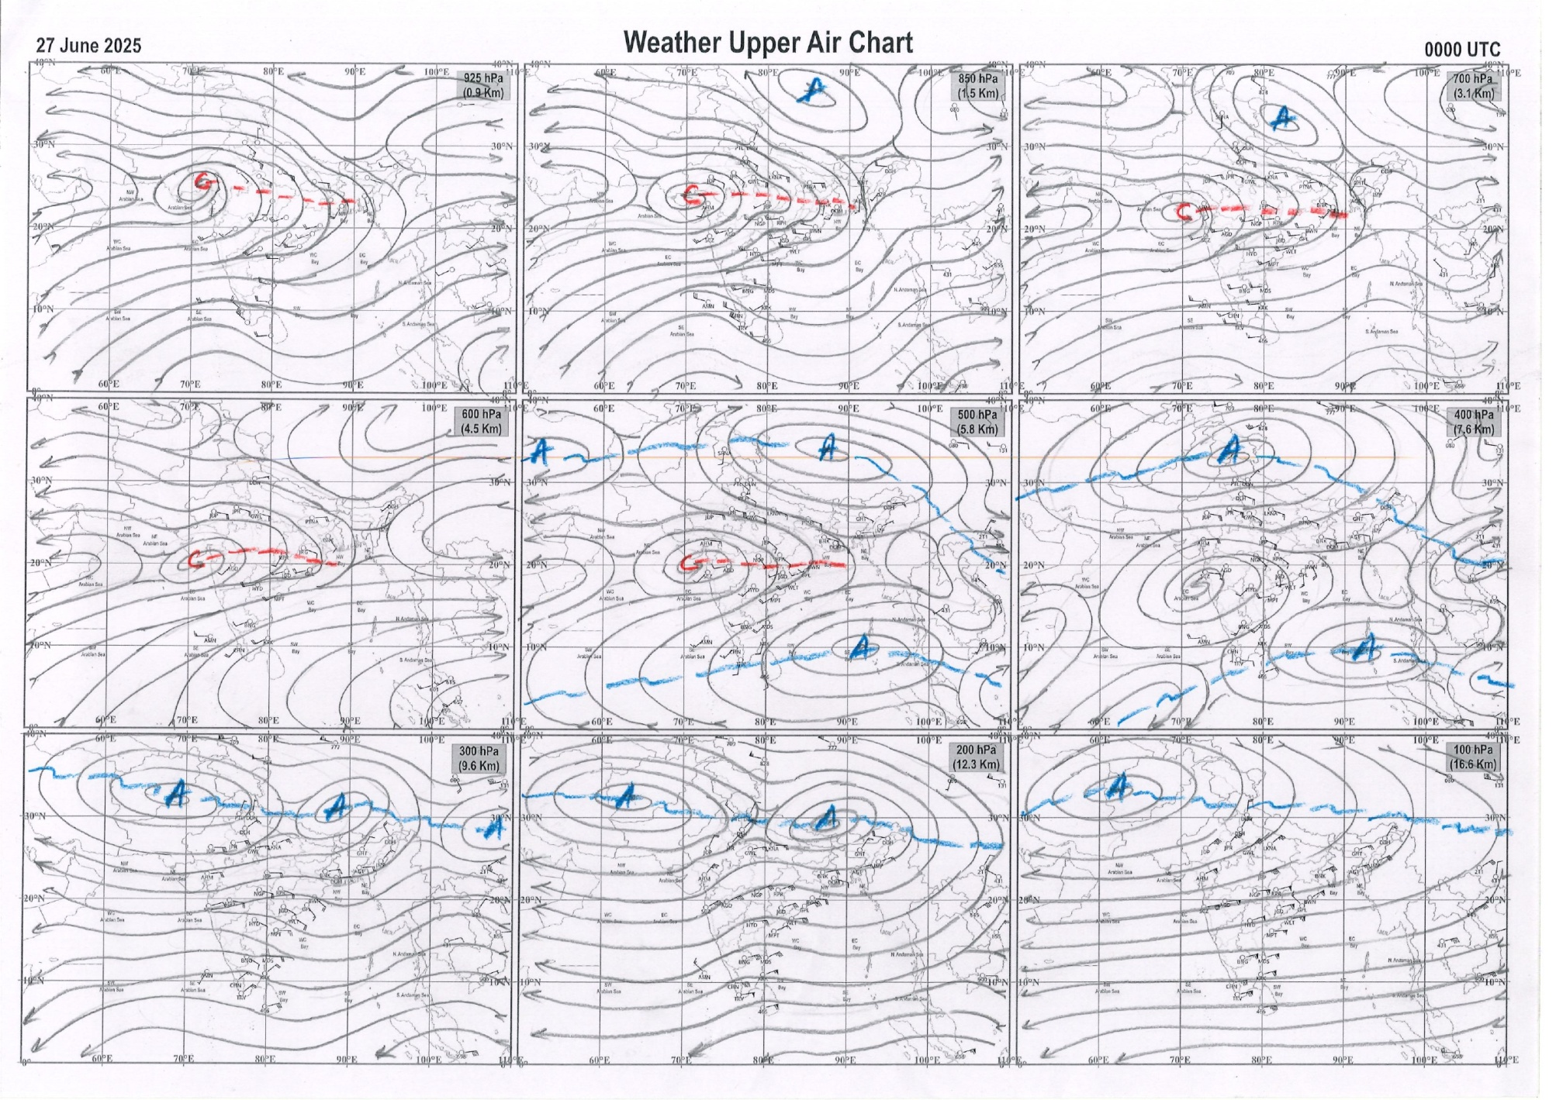
g.1. Analysed surface chart based on 03z observation | Fig.2. Analysed upper air chart based on 00z observation

Dr. S D Sanap.
Scientist ‘D’
CR & S Office, Pune  Issued at 1245 hrs. IST |  | Weather Forecasting Division  CR&S, Pune

Indian regions | Realised rainfall (chief amount in cm during past 24 hrs):
East | most places: Gangetic West Bengal and Jharkhand+  many places: Sub-Himalayan West Bengal & Sikkim+ and Odisha+++  a few places: Arunachal Pradesh, Assam & Meghalaya# and Nagaland-Manipur-Mizoram-Tripura  isolated places: Bihar  Khowang 24.5, Balikuda 14.5, Kakatpur 10.9, Gobindpur dvc 6.9, Buxaduar 6.5, Srijangram ARG & Diyakel khunti kvk AWS 6.3 each, Kurti t.e. 6.1, Cuttack 5.8, Chottabekra 5.3, D / Mohanbari AP 5.0, Mo saltlake 4.8, Tamenglong 4.6, Uluberia 4.4, Canning 3.9, Dumaria 3.4, Jamshedpur 2.5, Namsai 2.1, Rohtas 2.0, Imphal AP 1.5, Miao & Tadong 1.4 each, Bomdila 0.8, Dehri 0.6.
North | many places: east Rajasthan+++  a few places: Uttarakhand+, Punjab+, Himachal Pradesh++ and west Rajasthan+  isolated places: Uttar Pradesh, Haryana+ and Jammu-Kashmir and Ladakh  Pandoh 13.9, Sajjangarh SR 13.0, Bassi 11.3, Loharkhet 8.3, Fatehabad 7.6, Jogindarnagar 7.3, Suratgarh 7.0, Sanchore 6.8, Taran taran 6.5, Talwandi sabo 6.0, Sirsa 5.6, Narendranagar 5.3, Jaisalmer 4.6, Uttar kashi 4.2, Dungarpur tehsil SR 3.7, Jalandhar & Mandi 2.9 each, Chandanwari AWS 2.8, Churk & Talbehat 2.4 each, Robertsganj 2.3, Hissar 2.2, Srinagar AP & Rambagh AWS 1.7 each, Mahroni 1.1, Jhansi 0.9, Pratapgarh (t) 0.6.
Central | most places: west Madhya Pradesh+++, east Madhya Pradesh+ and Vidarbha+++  a few places: Chhattisgarh+  Khirkiya-arg 13.3, Mangrulpir 13.0, Mehkar 12.9, Udainagar 12.5, Rahatgarh 9.7, Pratappur 9.3, Shahpura 9.2, Darri 7.0, Indore 6.9, Wardha 5.9, Jashpurnagar 4.3, Jabalpur-aws 4.2.
Peninsula | most places: Gujarat Region+++, Konkan & Goa+, coastal Karnataka+ and Kerala+++  many places: Saurashtra & Kutch+++  a few places: Madhya Maharashtra+, Marathwada, coastal Andhra Pradesh, Telangana and south interior Karnataka+++  isolated places: Rayalaseema, Tamil Nadu+++ and north interior Karnataka  Agumbe emo 17.0, Malia 16.2, Mangrol (j) 15.4, Vadali 15.3, Keshod 13.9, Ernakulam south 12.3, Chinnakalar & Kayamkulam ARG 12.1 each, Jawhar 11.5, Idar & Worth estate cher 10.8 each, Dharoi colony 10.7, Karipur ap. 9.2, Castle rock 9.0, Matheran 8.4, Kammardi & Kottigehara 8.0 each, Gaganbawada 7.9, Sulya 7.6, Radhanagari 7.5, Mokheda fmo 7.3, Valparai PTO 7.1, Londa 6.3, Mahabaleshwar 5.9, Soegaon 5.5, Khanapur 4.5, Palakoderu 4.3, Kaikalur 4.2, Kannad & Panambur 4.0 each, Sultanabad & Manuguru 2.5 each, Narsapuram 1.5, Haveri PTO 1.3, Bhadrachalam 1.1, Venkatagiri 0.8, Sambhajinagarobsy 0.6, Tirupati AP 0.4, Gudur 0.3.
Islands | many places: Lakshadweep  a few places: Andaman & Nicobar  Agathi 1.5, Maya bandar 1.2, Hut bay 1.0, Amini 0.6, Long island 0.3.
Table 2. Forecast / warnings (distribution of rain / thundershowers) for 7 days (valid from time of origin upto 0830 hrs IST of next day)
Sr N. |  | Sub-division Name | Day 1 | Day 2 | Day 3 | Day 4 | Day 5 | Day 6 | Day 7 | Sr. No. | Sub-division Name | Day 1 | Day 2 | Day 3 | Day 4 | Day 5 | Day 6 | Day 7
 |  |  | 27 Jun | 28 Jun | 29 Jun | 30 Jun | 01 July | 02 July | 03 July |  |  | 27 Jun | 28 Jun | 29 Jun | 30 Jun | 01 July | 02 July | 03 July
 | 1 | Andaman Nicobar Islands | F  | W+ | W | F | F | F | F | 19 | west Madhya Pradesh | W++ | F+ | F +  | F +  | W++ | W++ | W ++
 | 2 | Arunachal Pradesh | S +  | F +  | F +  | F +  | F++ | F + | F + | 20 | east Madhya Pradesh | W ++  | F +  | F +  | W +  | W++ | W++ | W ++
 | 3 | Assam-Meghalaya | S+ + | S+  + | F+ + | F +  | F +  | F + | F + | 21 | Gujarat region | W ++  | W ++  | W ++  | W ++  | W ++  | W + | W +
 | 4 | Nagaland-Manipur-Mizoram-Tripura | F+++ | F+ + | F+ + | W +  | W +  | W ++ | W + | 22 | Saurashtra and Kutch | W #  | W++ | W+ | F+ | F+ | F + | W +
 | 5 | Sub Himalayan West Bengal/Sikkim | F +  | W +  | W + | W + | F + | W + | W + | 23 | Konkan and Goa | W ++  | W +  | W++ | W++ | W ++ | W++ | W +
 | 6 | Gangetic West Bengal | W+ | W  | W++ | W++ | W+ | F + | F | 24 | Madhya Maharashtra | S ++ | S ++ | S ++ | S ++ | S ++ | S ++ | F ++
 | 7 | Odisha | F + | F + | F +  | W ++ | W++ | F + | F + | 25 | Marathwada | I  | I | I | I | I  | S  | I
 | 8 | Jharkhand | W+ | W+ | W++ | W+ | W+  | W + | W + | 26 | Vidarbha | F++ | S  | S  | S +  | F +  | W + | F
 | 9 | Bihar | F + | F + | F + | F+ | F+ | F + | F + | 27 | Chhattisgarh | F +  | F +  | S +  | F +  | F ++ | F ++ | F +
 | 10 | east Uttar Pradesh | S  | F +  | F ++  | F +  | F ++  | F ++ | F +  | 28 | Coastal Andhra Pradesh and Yanam | F  | S  | I  | I  | S  | F | F
 | 11 | west Uttar Pradesh | I | S +  | F ++  | F +  | F ++  | F ++ | F +  | 29 | Telangana | S +  | I  | I  | I  | S  | S | S
 | 12 | Uttarakhand | F ++  | F ++  | W ++  | W ++ | W ++ | F +  | F +  | 30 | Rayalaseema | I  | I | I | I | I | I | S
 | 13 | Haryana,Chandigarh and Delhi | S +  | F +  | W ++  | W++ | W +  | F +  | S +  | 31 | Tamil Nadu, Puducherry and Karaikal | I +  | S +  | I | I | I | I | I
 | 14 | Punjab | S  | S +  | W++ | W +  | F  | S +  | S +  | 32 | Coastal Karnataka | W +  | W +  | W + | W | W + | W + | W +
 | 15 | Himachal Pradesh | W +  | F +  | W++  | W + | F + | F + | F + | 33 | North interior Karnataka | S | S | I | I | S | S | S
 | 16 | Jammu-Kashmir and Ladakh | F + | S +  | S + | S  | S  | S  | S  | 34 | South interior Karnataka | S + | S | I | I | S + | S + | S +
 | 17 | west Rajasthan | F + | F+ | S+ | S  | I  | I  | I+ | 35 | Kerala and Mahe | W ++  | W++ | F + | S | S | F | W +
 | 18 | east Rajasthan | F++  | F + | F+ | F+  | F+  | S+ | F++ | 36 | Lakshadweep | W  | W  | F | S | S | F | W
Legends: D = Dry I = Isolated S = Scattered F = Fairly widespread W = Widespread #= heavy to very heavy rain at a few places with extremely heavy rain at isolated places +++= heavy rain at a few places with very heavy rain at Isolated places ++= heavy to very heavy rainfall @=Isolated exceptionally heavy rainfall + = heavy rain ●/*= rain or snow ♦ = very light rain ≡=fog= thunderstorm with lightning =Squall / Gusty / gale / strong wind ­ =cold wave/cold day += heat wave/warm night/hot and humid weathe r=Duststorm =ground frost = Hail

Fig. 4: Districtwise warnings for five days for Maharashtra State
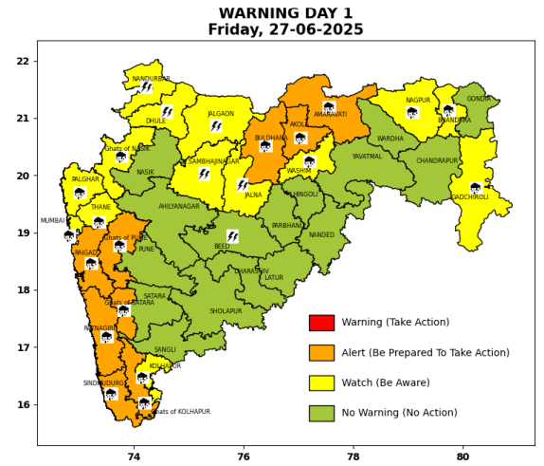 | 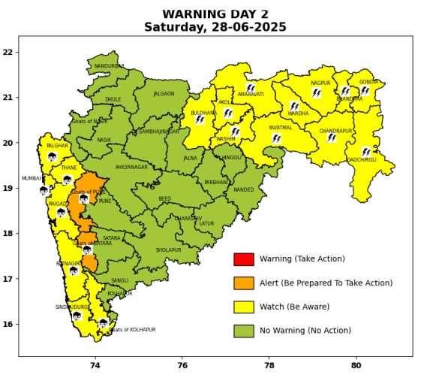 | 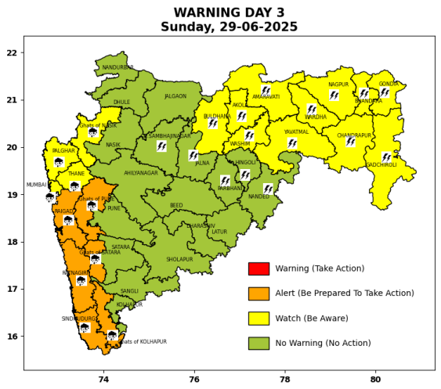 | 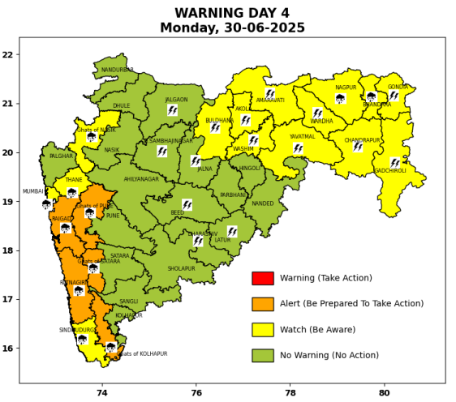 | 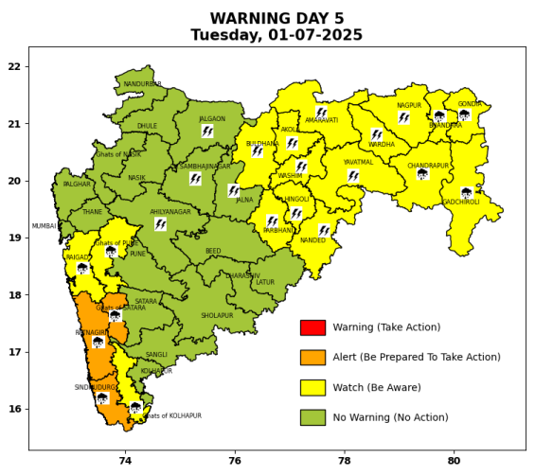

Pune, Lohegaon and Pashan observations at 0830 hrs. IST of Today
 | Temperature (°C) |  |  |  |  | Humidity (%) |  |  |  | Rainfall (mm)
 | Max.  past  24 hrs | Dep.  from  normal | Min.  past  24 hrs. | Dep.  from  normal | Dry  Bulb | At 0830 hrs. IST | Dep.  From  normal | At 1730  hrs. IST of y’day | Dep.  from  normal | Past  24 hrs. | Since  1st June | Dep.  from  normal
PNE | 29.5 | -0.2 | 23.0 | 0.2 | 25.6 | 80 | -1.0 | 81 | 6 | 0.4 | 261.1 | 125.6
PSN | 28.3 | - | 21.7 | - | 24.3 | 94 | - | 86 | - | 1.0 | 294.5 | -
LHG | 31.3 | 0.3 | 24.7 | 3.7 | 26.7 | 74 | -6 | 78 | 10 | 0.6 | 242.4 | 152.6

 |  |  |  |  |  |  | Local (Pune and neighbourhood) forecast
Max./Min. Temperature (°C) |  |  |  |  |  |  |  |  | Weather
Date | Pune | Pashan | Lohegaon | Chinchwad | Lavale | Magarpatta | NDA | Koregoan Park
27/06/25 | 29 / 23.0* | 28 / 21.7* | 29 / 24.7* | 28 / 22.9* | 28 / 22.4* | 30 / 24.4* | 28 / 23.3* | 29 / 24.6* | Generally cloudy sky. Light rain very likely. (Heavy to very heavy rainfall at isolated places in ghat areas)
28/06/25 | 29 / 23 | 28 / 22 | 29 / 25 | 28 / 23 | 28 / 22 | 30 / 23 | 28 / 23 | 29 / 25 | Generally cloudy sky. Light rain very likely. (Heavy to very heavy rainfall at isolated places in ghat areas)
29/06/25 | 30 / 24 | 29 / 23 | 30 / 26 | 29 / 24 | 29 / 23 | 31 / 24 | 29 / 24 | 30 / 26 | Generally cloudy sky. Light rain very likely. (Heavy to very heavy rainfall at isolated places in ghat areas)
30/06/25 | 30 / 24 | 29 / 23 | 30 / 26 | 29 / 24 | 29 / 23 | 31 / 24 | 29 / 24 | 30 / 26 | Generally cloudy sky. Light rain very likely. (Heavy to very heavy rainfall at isolated places in ghat areas)
01/07/25 | 30 / 24 | 29 / 23 | 30 / 26 | 29 / 24 | 29 / 23 | 31 / 24 | 29 / 24 | 30 / 26 | Generally cloudy sky. Light rain very likely. (Heavy rainfall at isolated places in ghat areas)
02/07/25 | 29 / 23 | 28 / 22 | 29 / 25 | 28 / 23 | 28 / 22 | 30 / 23 | 28 / 23 | 29 / 25 | Generally cloudy sky. Light to moderate rain very likely. (Heavy rainfall at isolated places in ghat areas)
03/07/25 | 28 / 22 | 27 / 21 | 28 / 24 | 27 / 22 | 27 / 21 | 29 / 22 | 27 / 22 | 28 / 24 | Generally cloudy sky. Light to moderate rain very likely. (Heavy rainfall at isolated places in ghat areas)
Rainfall Distribution |  |  | Rainfall Categories | Rainfall (mm) |  | Cloud condition |  |  |  | Rainfall Intensity |  | Range
Widespread (W) | 76-100% |  | Very Light rain | Trace to 2.4 mm |  | Mainly clear sky |  | 1-2 oktas |  | Light Spell |  | 1 cm/hr
 |  |  | Light rain | 2.5 to 15.5 mm |  | Partly cloudy sky |  | 3-4 oktas |  | Moderate Spell |  | 1-2 cm/hr
Fairly Widespread (FW) | 51 – 75% |  | Moderate rain | 15.6 to 64.4 mm |  | Generally cloudy sky |  | 5-7 oktas |  | Intense Spell |  | 2-3 cm/hr
Scattered (S) | 26 – 50% |  | Heavy rain | 64.5 to 115.5 mm |  | Overcast |  | 8 oktas |  | Very Intense Spell |  | 3-5 cm/hr
isolated (I) | 1 – 25% |  | Very heavy rain | 115.6 to 204.4 mm |  |  |  |  |  | Extremely Intense Spell |  | 5-10 cm/hr
D (D) | No Rain |  | Extremely heavy rain | ≥ 204.5 mm |  |  |  |  |  | Cloudburst |  | > 10 cm/hr
Probability Terms in %: |  |  | Heavy snow | 6.5 to 11.5 cms water equivalent of rain
unlikely | < 25 |  | Very heavy snow | 11.6 to 20.4 cms water equivalent of rain
likely | between 25 50
very likely | between 51 75
most likely | >75
* = realized temperature
Mumbai (Colaba) |  |  |  | Nagpur (AP)
Date 2025 | T max °C | T min °C | Weather | T max °C | T min °C | Weather
27/06 | 30 | 27 | Generally cloudy sky with heavy rainfall. | 34 | 24 | Generally cloudy sky with heavy rain. Thunderstorm accompanied with Lightning & gusty winds(30-40kmph).
28/06 | 31 | 26 | Generally cloudy sky with moderate rain. | 34 | 25 | Generally cloudy sky with a few spells of rain or thundershowers accompanied with Lightning.
29/06 | 32 | 25 | Generally cloudy sky with heavy rainfall. | 34 | 26 | Generally cloudy sky with a few spells of rain or thundershowers accompanied with Lightning.
30/06 | 32 | 25 | Generally cloudy sky with heavy rainfall. | 33 | 25 | Generally cloudy sky with a few spells of rain or thundershowers accompanied with Lightning.
01/07 | 31 | 25 | Generally cloudy sky with moderate rain. | 33 | 25 | Generally cloudy sky with a few spells of rain or thundershowers accompanied with Lightning.
02/07 | 31 | 26 | Rain. | 31 | 25 | Generally cloudy sky with possibility of rain or thunderstorm.
03/07 | 30 | 26 | Rain. | 31 | 24 | Generally cloudy sky with possibility of rain or thunderstorm.

